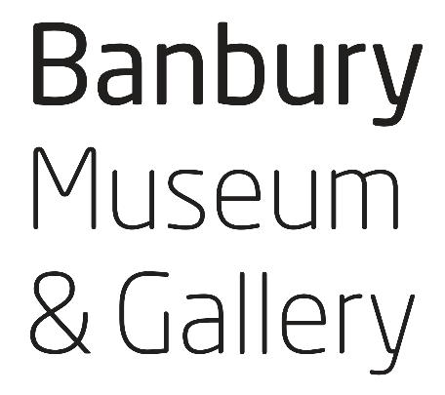
Terms and Conditions for Group Visits,
Workshops and Outreach Sessions


1. Booking
a. Booking is essential
It is very important for all groups to book before visiting the Museum, even if the visit is quite informal.
b. Confirmation
When the details of your visit or session are agreed, we will send a booking form summarising the arrangements made between you and the Museum. Your booking is confirmed when you have completed and returned the form to us. Before this point, it may not always be possible to hold a date for you, if demand for bookings is high.
c. Cancelling or changing your booking
If you need to cancel or change your booking after sending back the form, please tell us as soon as possible. We will do our best to make the changes, or offer a new date, but cannot guarantee to do so.
If the cancellation or changes are made less than two weeks before the date of your session, there is a charge of £25, even if we cannot offer an alternative.
d. Cancellation or changes by the Museum
The Museum will only cancel or modify your session if we have a major H&S or staffing issue. We will give as much notice as possible, and do our utmost to offer a comparable session, at the Museum or as outreach, at the earliest opportunity.

2. Charges and payment
a. Charges
The overall cost of your session will be explained when you enquire, and is stated on your booking form. For sessions priced per head, we cannot offer a reduction if your group is smaller on the day.
b. Payment
The Museum will send an invoice after the session, which is payable 14 days after the date of the invoice.
3. Health and safety
The primary responsibility for the health, safety, behaviour and safeguarding of the group lies with you, as you know the individual participants’ needs. The information that the Museum provides - such as a general Risk Assessment, suggested ratios and notes about our facilities – are for guidance only. Please make sure you have all the health and safety requirements for your individual group, including first aid and medical equipment.
In accordance with our Safeguarding Policy, Museum staff do not offer Regulated Activities (ie activities where Museum staff are alone or in frequent contact with children or vulnerable adults). Museum staff will therefore not be alone with members of your group. While most of our educators have up to date DBS certificates, some staff or volunteers who assist with sessions may not have certificates.
For outreach sessions we will, of course, follow your Safeguarding Policy and bring ID and certificates as required.
It is essential that your staff are responsible for the group and are present in sufficient numbers for the needs and behaviour of the group, wherever the session is held.

4. Logistics and equipment
Please tell the Museum as much information as possible about your group and your expectations of the session, beforehand.
So that you, as a group leader, have full information about the Museum, we welcome pre-visits at any stage in the booking process. If possible, please let us know when you are coming. If you would like to see the behind-the-scenes areas used for group visits, or wish to speak to the learning team, it is essential to book ahead. Pre-visits are highly recommended if members of your group have significant additional needs.
For outreach sessions, we will discuss with you which rooms, equipment and parking spaces are available for Museum staff, and when. Please let us know as soon as possible if you need to make changes to these arrangements so that the session can be adapted accordingly.

5. Privacy
a. GDPR
The contact details you give to the Museum are subject to General Digital Protection Regulation (GDPR) legislation.
b. Photography
Museum staff will not take photographs of the group without your express permission and with your full agreement about the future use and storage of images.
Most Museum staff are happy to be photographed by group leaders. However, we sometimes have volunteers, work experience students or others who may not wish to be photographed, so please check if possible.

6. Complaints and feedback
The Museum welcomes feedback at any time; we routinely send requests for feedback after group visits. In addition, if you have a comment, complaint or want to raise an issue please contact us at enquiries@banburymuseum.org

